Name: Nafinur Leo

Id: 20-42195-1

Section: W

Simulation1:

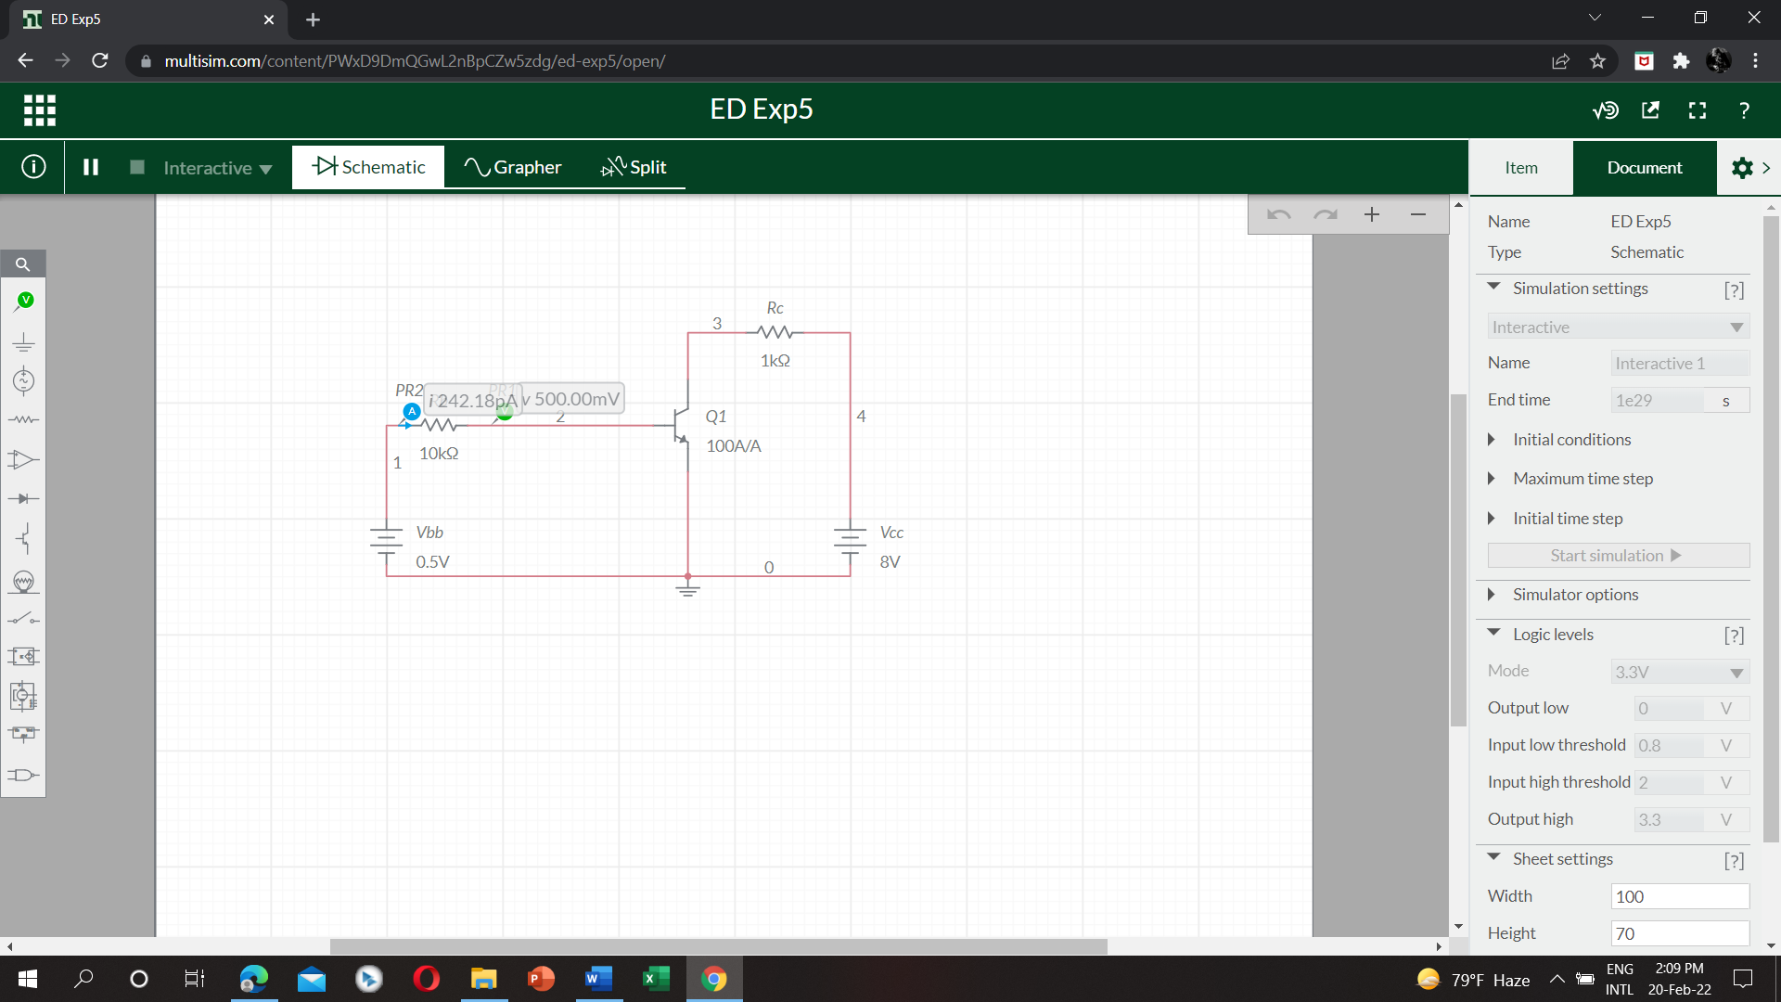

Table:

|  |  |  |  |  |  |
| --- | --- | --- | --- | --- | --- |
| Vcc=8V | | | Vcc=16V | | |
| Vbb(V) | Vbe | Ib | Vbb(V) | Vbe | Ib |
| 0 | 80 nV | 8 pA | 0 | 160 nV | 16 pA |
| 0.5 | 500 mV | 242.18 pA | 0.5 | 500 mV | 234.18 pA |
| 1 | 793.02 mV | 20.69 microA | 1 | 793.02 mV | 20.69 microA |
| 1.5 | 823.65 mV | 67.63 microA | 1.5 | 823.65 mV | 67.63 microA |
| 2 | 827.79 mV | 117.22 microA | 2 | 837.65 mV | 116.23 microA |
| 2.5 | 828.17 mV | 167.18 microA | 2.5 | 845.62 mV | 165.44 microA |

Simulation2:

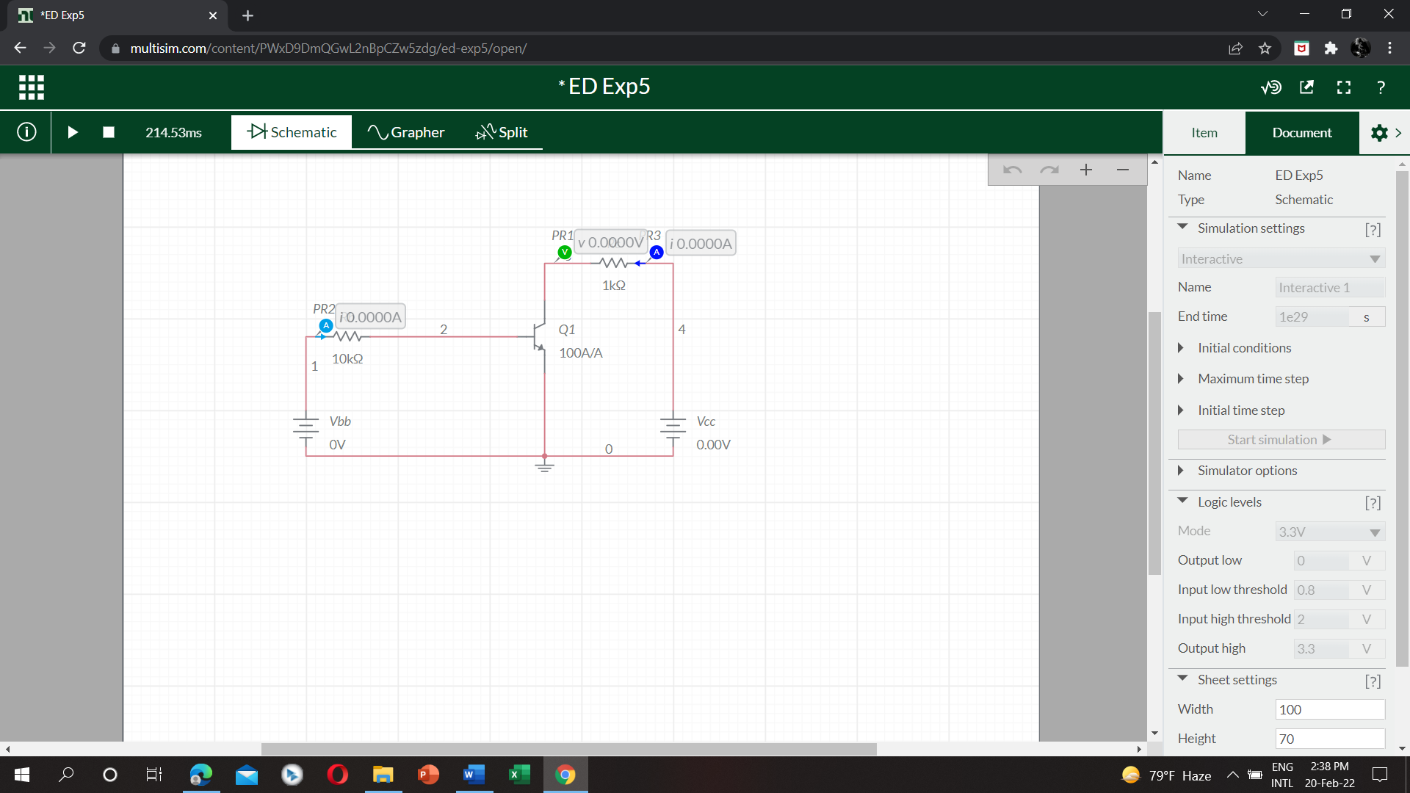

Table:

|  |  |  |  |  |  |  |  |  |
| --- | --- | --- | --- | --- | --- | --- | --- | --- |
| Ib=0 microA | | | Ib=50 microA | | | Ib= 100 microA | | |
| Vcc(V) | Vce | Ic | Vcc(V) | Vce | Ic | Vcc(V) | Vce | Ic |
| 0 | 0 | 0 | 0 | 14.54 mV | 14.53 microA | 0 | 15.79 mV | 15.78 microA |
| 4 | 4 | 12 pA | 4 | 149.57 mV | 3.87 mA | 4 | 111.79 mV | 3.88 mA |
| 8 | 8 | 24 pA | 8 | 2.99 V | 5 mA | 8 | 166.34 mV | 7.84 mA |
| 12 | 12 | 36 pA | 12 | 6.99 V | 5 mA | 12 | 2.91 V | 9.09 mA |
| 16 | 16 | 48 pA | 16 | 10.99 V | 5 mA | 16 | 6.91 V | 9.10 mA |